Humanitarian Networks and Partnerships Week (HNPW)

Physical HNPW Exhibition Area at the CICG

The HNPW physical Exhibition Area will be exposed at the International Conference Centre Geneva (CICG). This is a non-commercial space to display information about areas of work in humanitarian action.
Rules of engagement for exhibitors

Standard equipment for exhibition stands (provided at no cost by the CICG)
- Standard configuration
  - One table (length:150, width: 75cm, height: 65 cm)
  - Two chairs
  - WiFi
  - Electricity
  - One Board:
Whiteboard  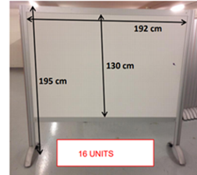 | Pinboard  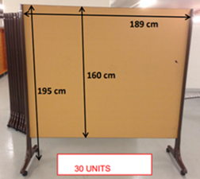 | Whiteboard magnetic  h: 189 cm, w: 198 cm  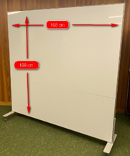

Equipment for photo exhibition stands
Per photo exhibition, up to 5 magnetic white boards  Whiteboard (magnetic, h: 189 cm, w: 198 cm)  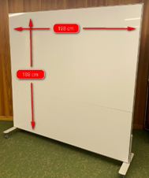 | Optional (at own costs): Photo racks  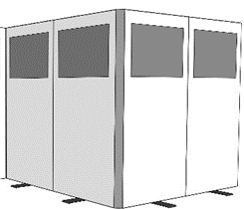

- Deviations from the standard configuration are to be requested in the online registration form under “Remarks physical exhibition stand”. Requests will be validated by the HNPW Secretariat and the CICG. Exhibitors will be informed bilaterally.
- The information displayed may include, posters, banners, photos, or other visual products (e.g. video).
- Technical and other equipment (e.g. computers to display videos, totems) must be provided by the exhibitor
- The exhibition booths can be set up on Friday as of 09:00 or on Monday between 07:30 – 10:00.
- Preferably, exhibition booths should be available throughout the face-to-face week. Exceptions (i.e. later setup or earlier dismantling) to be coordinated with the HNPW secretariat (ocha-hnpw@un.org)
- Preferably exhibition booths should be manned, at least during breaks (10:30-11, 12:30-14:00, 15:30-16:00). If not manned, the next planned presence of staff at the booth should be indicated.
- Photo exhibitions may be displayed in separate spaces outside the main exhibition area.

Administrative and logistics arrangements
- Address of the venue
  - Centre International de Conférences Genève
  - Rue de Varembé 17
  - 1202 Genève, Switzerland
- On arrival at the venue, exhibitors will meet with the Exhibition Coordinator at the reception desk, who will guide them to their assigned booth.
- Exhibitors may park vehicles temporarily in front of the venue to unload equipment.
- Please note that there are no printing facilities at the venue.
- Exhibition booths can remain set up during the night. The venue is locked and guarded outside working hours, but exhibitors are responsible for their equipment, material, and belongings. It might be considered to remove expensive equipment outside working hours.
- Security measures:
  - The CICG is under 24/7 video surveillance, however, the various materials and goods used or stored by each exhibitor remain subject to the responsibility of the exhibitor.
- Shipping of material
  - Exhibitors can deliver material in limited quantities before the event. The delivery date and the authorized volume needs to be clarified with the venue focal point prior to the shipment.
Documents | Material
Address to:  HNPW  c/o CICG  17 rue de Varembé  Case postale 13  1211 Genève 20 | Address to:  HNPW  c/o CICG  Cour de livraison  Chemin Camille-Vidart  1202 Genève

- For both types, include the following reference:
  - HNPW xxxx
  - Booth focal point: Name and phone number.

- If you are using UPS, DHL, FEDEX, etc. please indicate the name of the client as the importer of the material. The CICG is only the delivery address.

- Deliveries
  - The delivering person has to announce him/herself at the externals terminals to access the delivery court.
  - The CICG receives the materiel but is not responsible for delivery mistakes.
  - The costs associated with the deliveries (VAT, customs fees, etc.) will be charged to the customer.
  - The CICG will not pay anything for the deliveries. Cash on delivery shipment will be refused.
  - The delivering person must bring the materiel to the storage zone.
  - No discharging will be made by the CICG for insurance purposes.
  - Deliveries are made to the delivery court. Only semi-trailers are allowed to discharge the material on the CICG’s esplanade.
  - The timeframe for set up and dismantling will be coordinated by the HNPW Secretariat.
  - For the use of the freight elevator, an access badge must be asked at the reception, between 07:00 and 19:00, in exchange of an ID card.

- Returns
  - The exhibitor is responsible for the return shipment of packages, which must take place within 48 hours of the end of the event.
  - The exhibitor shall ensure compliance with applicable regulations regarding the import of goods from the place of origin to the conference center (e.g. customs)
  - The CICG does not have a dedicated storage area for the exhibition material. No empty packaging (crates, cardboard boxes etc.) may be stored on-site
  - CICG partner InterExpoLogistics (IEL), specialized in material transportation, transit, and storage, is at your disposal if you have questions.
  - All bulky rubbish must be evacuated by the exhibitor.
  - Seven days after the Event. FIPOI reserves the right to dispose of any goods, materials, equipment or documents left, not appropriately returned, lost or forgotten on the site by the client or a third party

- Additional equipment (e.g. screens/monitors) can be rented at the cost of exhibitors at the venue. Contact details at the CICG
  - Mr. Joel Diaz
  - j.diaz@fipoi-conferences.ch
  - +41 22 791 9154

For further information or clarification, please contact the HNPW Secretariat at ocha-hnpw@un.org

